ANNEX 3.1-B: STANDARD NETWORK TOPOLOGY DIAGRAM
SHOC ↔ NDMA ↔ Field Connectivity Architecture

Topology Layer Architecture
Layer | Components | Functions
A. Core Layer (SHOC HQ / Situation Room) | • Redundant VSAT + Starlink uplink • Core firewall & VPN concentrator • PMIS dashboard • Cloud Node (Azure SA Region) | • Primary command & control • Data aggregation & analysis • Secure external connectivity • Continental coordination
B. Distribution Layer (NDMA HQ / EOCs) | • Encrypted VPN tunnels to SHOC • HF/VHF Gateway • LTE fail-over router • Local server infrastructure | • National coordination • Regional data relay • Interoperability gateway • Backup connectivity
C. Field Layer (Forward Teams) | • Portable VSAT or Starlink • Local Wi-Fi access point • VHF/HF handheld radios • Solar-powered battery + UPS | • Frontline communications • Field data collection • Last-mile connectivity • Mobile coordination

Data Flow Diagram

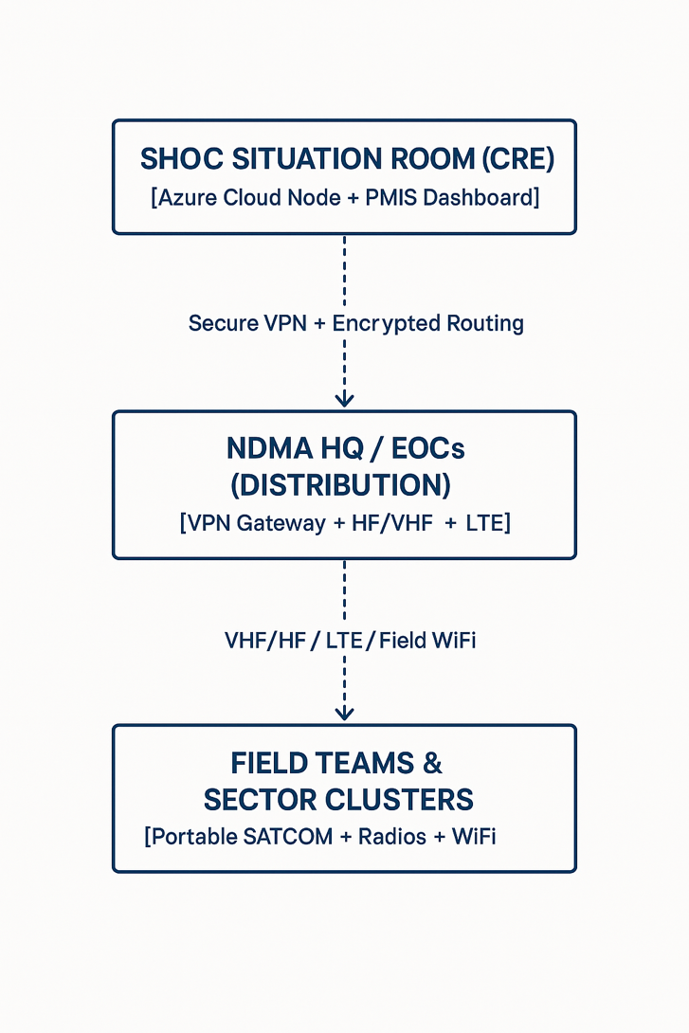

Security Overlay Requirements
Security Control | Implementation Standard
Authentication | Two-Factor Authentication (2FA) mandatory on all SHOC-bound connections
Data Resilience | Cloud mirroring every hour to Azure South Africa Region
Failover | Automatic fail-over between SATCOM + LTE (< 30 second switchover)
Encryption | AES-256 encryption on all data in transit and at rest
Monitoring | 24/7 SOC monitoring with SolarWinds/Zabbix alerting

